Cowley and Uxbridge Community Boaters’ (CUB) Meeting
held on 24 April 2013 at Denham Yacht Station
THOSE PRESENT: See Appendix I
Steve Jay welcomed everyone to the meeting and then Louise Yeoman read a brief and succinct introductory summary of why CUB was formed, embarked on improving communications with the Canal and River Trust (CRT) and has been engaged in trying to find a solution to the problems caused by a scarcity of affordable moorings in the CUB area (Appendix II), viz the proposed Roving Permit (Appendix III).
Charles Tustian (Chairperson) then introduced the CRT representatives and invited Sally Ash (CRT Head of Boating) to give the CUB meeting feedback on the current developments. First, she paid tribute to members of CUB, in particular Steve and Louise, for their constructive and positive attitude in looking for solutions to the perceived problems in the area. CUB was the first group with such a positive attitude and this was very encouraging and she was committed to helping to find a solution. She stated that she would not be able to provide all the answers about the proposed Roving Permit at the meeting, because it would be a pilot scheme that would inevitably need “some wrinkles ironed out”. She had presented the latest update to her CRT bosses the previous week and they were broadly supportive.
She presented a research questionnaire (Appendix IV) in pilot form that has the aim to help CRT to understand the needs and lifestyles of Continuous Cruisers with established roots on the Grand Union south of Bulbourne, who find it difficult to comply with the current Mooring Guidance for Boats without a Home Mooring. She stressed that it was very important that the processes were transparent – access had to be fair and equal for all canal users. She also stressed that whilst it was important to provide individual personal information (to ensure that responses represent the views of individual boaters), this would not be used as evidence in relation to any enforcement activity, whether current or future. This is just a pilot form for this meeting, but will be refined and will form the basis of a wider survey to identify the needs of established boaters in the area.
She then outlined the policy context. CRT Trustees have requested reviews around Continuous Cruising (CC) and mooring along the towpath in four main areas:
- Investigate increasing the supply of long term permit moorings (community moorings) that would have to be done to a professional standard. This was something that perhaps CUB could assist with by research to find areas that required for example, dredging in order to be suitable.
- To achieve better management on visitor moorings. The report from the consultation process on the southeast region is imminent. There were 350 responses and quite a few of the suggestions arising from these have been integrated into the report.
- There has to be clarity about the CC’s generic movement requirements that CRT will propose, suggesting neighbourhoods and distance. She asked Louise to circulate copies of the map of the area between Croxley Green to Stockley Park (Appendix V). She introduced Sorwar Ahmed, the new Boater Liaison Manager, who has just joined CRT and this is part of his portfolio. Essentially a genuinely continuously cruising boater has to pass through each “neighbourhood”, staying for no longer than 14 days in each. It is expected that the boater would take a few months to cover the whole distance and thus, be compliant. She added, that if it works in this area, it would help roll it out over the rest of the Waterways.
- Identifying the needs of established boaters in the area - the so-called “Grandfather Rights” – which is where the pilot research questionnaire document comes in. CRT would want to grant the Roving Permit to as many of them as possible, but is not qualified to make judgement on the basis of need.
The price of the Permit has not been finalized, direction needs to come from the CRT bosses and it would need to be tested. If it is too low, it would create dissent among other customers. Sally Ash’s own thoughts about this would be in the region of 50 Pounds per metre per year (which would be 800 Pounds a year for a 60 foot boat).
She then outlined the next steps:
The questionnaire will be run over the internet and continuous cruisers repeatedly sighted on the southern GU invited to complete it during May. This should show the potential “nub” areas and will also aid mapping the capacity. The backroom administrative detail for the scheme would also have to be set up. By mid July it was hoped that blueprint mockups could be produced. CRT would then hold a workshop with invited participants to go through them (approximately 20 people). If all goes well, it should be ready to launch it in August. The Permit for the CUB area would be a pilot one and the first scheme, valid for 12 months and, subject to any changes or problems with the scheme, renewable. There would be a review process after three months (December) and if necessary fine-tuned.
Charles then thanked her and opened the meeting for questions.
The mapping data collection would be along the entire length of the area in Appendix V. Plus, other maps will become available in due course.
Where will the income from the Roving Permit go? Ideally at least some of it would be used for improvements in the area concerned. Sally will seek support for this approach from the Trust’s executive. .
The Roving Permit would not be a fixed mooring, but it would buy one out of CC rules. One must move between at least three neighbourhoods every 14 days (not 28 days as stated in Appendix III) and over a distance of only about 5 miles and therefore not a continuous journey. The change to 14 days had come as a result of some complaints from permit mooring holders. It might be possible to look again at 28 days in the future.
In answer to a question with regard to boaters with health and disability issues, Sally Ash responded that CRT cannot assess cases of need. She added that there might be a need for a mediator in such cases.
If a boater had been on a winter mooring in the CUB area over the past winter, they could still be eligible for a Roving Permit. In answer to another question with regards to whether the 14 day restriction would still count in harsh weather conditions and whether taking a subsequent winter mooring would be detrimental; she responded that the whole winter mooring scheme had not proved to be popular for a variety of reasons and clarity would be needed with regard to the interaction between the permit and winter mooring. It might prove to be better to have a more generous stay time in the winter.
The condition of the Slough Arm was raised, with regard to it being included in the map on Appendix V for CC purposes. It is a crime hot spot as a result of too few boats being able to navigate it. It needs urgent dredging and becomes infested with weeds. There is also now a landslip on the stretch. John Dodwell (CRT Trustee) noted that he intended to cruise up the Slough Arm in the near future, in a boat with a 3 foot draught. CUB members wished him luck!
How long would the pilot roving permit be for? Initially 12 months, being renewable if successful. It is envisaged as an extra service from CRT to avoid being penalized in the current system. It would be seen as a home mooring inasmuch as being tied to an area (three small neighbourhoods).
The point raised as to whether the services (water, elsan, pump out) in the area be sufficient to cope with those on Roving Permits was noted as something to be considered in the review.
There are not currently plans to charge extra for widebeams for a Roving Permit.
The Roving Permit will be a “once off” – once it is given up, one cannot get it back. Only those with ‘grandfather rights’ will be eligible, and the permit will not be transferable.
In answer to question about whether Hillingdon Council would include the Roving Permit in housing benefit criteria, Jenny Dibstall (Senior Waterways Chaplain, Salvation Army) briefly reported back on a meeting she had had with them on 16 April . Full details of this are in Appendix VI.
Boaters who register their interest in the proposed Permit will not be free from the enforcement process prior to the implementation of the Permit.
Consistency in enforcement process: In the next quarter there will an increased focus on CC’ers who don’t move at all as well enforcing the 14 day rule.
The incentive for a boater to take up the roving permit is that they do not have to move so far because they are not a CC’er.
Sally Ash undertook to try to investigate the moorings at Cowley South offside being reinstated.
There will probably be some minor dredging undertaken in identified shallow places, so that boaters with Roving Permits are able to stay back from visitor mooring points and so support this proposal.
Steve Jay commented that there has to be an amicable agreement on distance for CC and that it was better to work together to agree a distance. Charles added that the distance would vary according to where on the Waterways network.
Sally Ash again asked those present to fill in the pilot questionnaires and to hand them in either to her or Louise at the meeting, or post them to her at Canal River Trust, First Floor (North), Station House, 500 Elder Gate, Milton Keynes, MK9 1BB. The results will be used to refine the questions for the survey.
Charles thanked everyone for coming and noted that it was much more constructive to work together to find solutions.
Meeting ended just before 21h00

APPENDIX I
CUB presents an evening with the Canal and River Trust
24th April at Denham Yacht Station

Canal and River Trust Representative's
Sally Ash Head of Boating
John Dodwell CRT Trustee
Peter Palmer Senior enforcement officer

Chairperson Charles Tustian CUB secretary Caz Thomas

Senior Waterways Chaplain Jenny Dibsdall
John Sloan Alan Fincher

Cowley and Uxbridge community Boaters.

Steve Jay Representative Louise Yeoman Representative
Michelle Riley Michelle Andrews
John Daniels Kim Pollard
Robert Beard Michael Duthie
Ian Duthie Brian Hobatt
Peter Murphy Neil Lawson
Ali Laker Chris Cochrane
Neil Searle Neil Hedger
Mick Vega 5 Josie and Sarah Green

Rickmansworth Group
Tony Peacock Representative Bob Chilton Representative
Malcolm Barr Patrick Cull
Mark Hughes

Dacorum Group
Heidi Sigger's Representative Peggy Melmoth Representative
Sid Reed Lina Noles

Milton Keynes Group
Molly Carson Representative Julie Smith Representative
Rob Smith

Apologies Gerald Vince (CUB) Christine Thompson (Ricky)

APPENDIX II
A brief introduction as to why Cowley and Uxbridge community Boater’s requested more affordable moorings.

Cowley and Uxbridge community Boater's came together as a response to enforcement being strengthened in this area. The aim being to provide advice and support to ensure all CUB boater's were best prepared to avoid enforcement. Our meetings focused on encouraging all continuous cruisers to CC within the rules and regulations of their licence. Boater's who were not able to do this were shocked to find they were perceived as a problem and had been labelled as non compliant continuous cruisers. Not wanting to be aproblem, but not being able to secure the rarely available local on line home moorings, either being outbid or finding the guide price unobtainable, CUB was anxious to find a solution. We all agreed improving communication with the Canal and River Trust was paramount, and to find out what help was available to boaters to prevent them overstaying.
We realized to continue living in this area more affordable moorings would be needed for local boaters, who wished to legitimately stay in the area free from the fear of enforcement. Many of whom have health, work, family and educational commitments locally and have grown roots as it were, by life circumstance's.
We feel the roving permit is an affordable mooring option, we have 18 CUB boaters, who predominantly use the Cowley and Uxbridge area as a CC base. All would like to take the roving permit option, until their circumstances change and they are able to secure online home moorings.
It is essential the roving permit is affordable to cater for people who have a low to modest income, but who are just over the threshold to be entitled to housing benefit. It is also essential that it is offered to all people who CUB feel have grandfather rights to a roving permit. They may not of come under the enforcement umbrella as yet, but fear enforcement and want to find a solution and are willing to pay a fair and reasonable amount to stay living on their boats.
Steve Jay and myself (Louise Yeoman) as CUB representatives welcome the introduction of the roving permit in the CUB area, we believe it represents an amnesty between CUB and the CRT. Providing boater’s with the opportunity to secure an affordable mooring close to the commitments that tie them to the Cowley and Uxbridge area and gives them an option other than enforcement.
We welcome the representatives from the Rickmansworth, Dacorum and Milton Keynes community boating groups here tonight, who mirror our experiences in their area’s and would like to see the roving permit rolled out and offered to the boaters they represent.

APPENDIX III
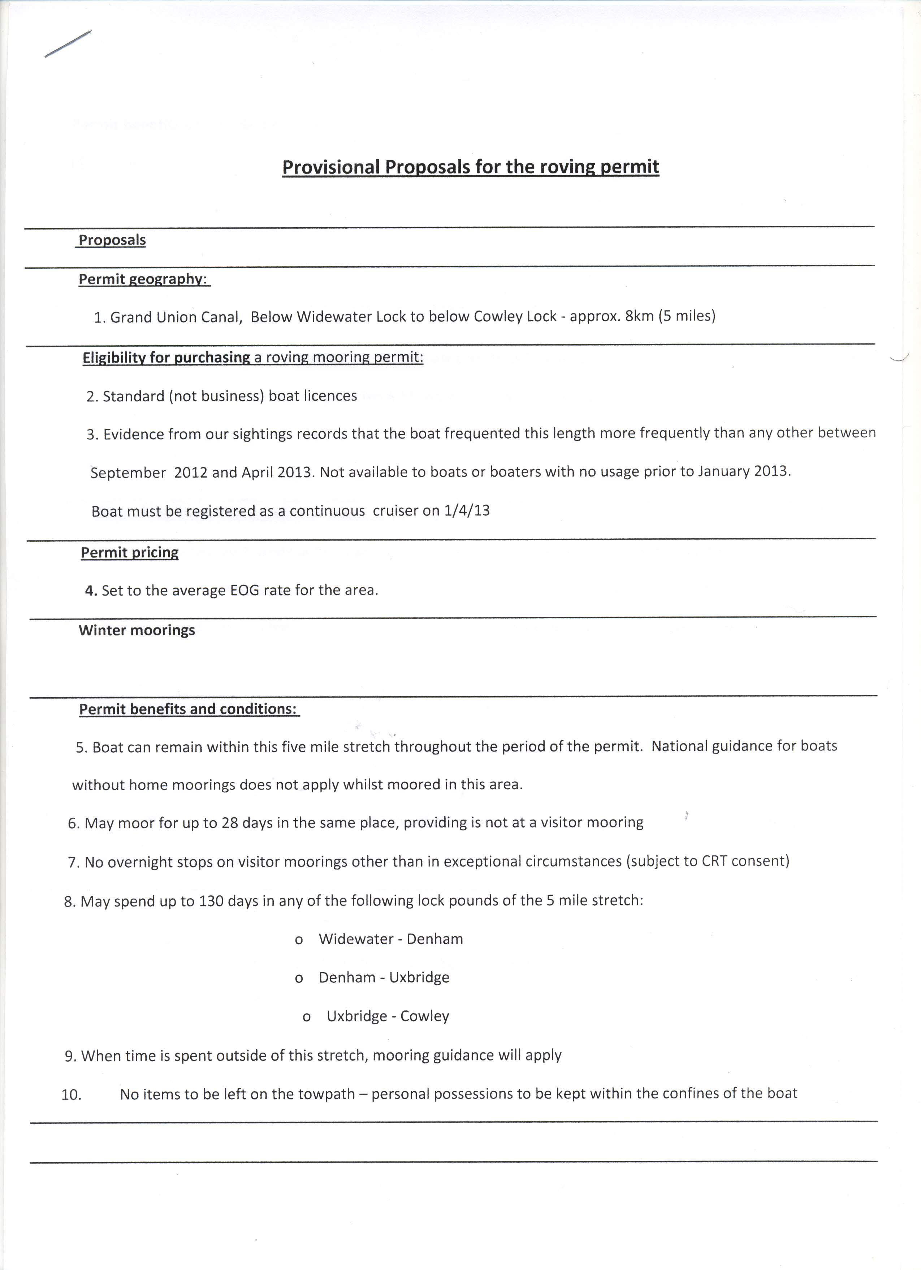
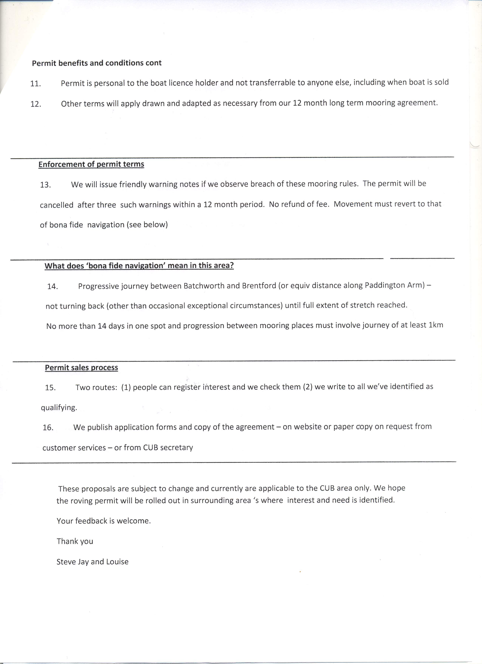
APPENDIX IV



RESEARCH QUESTIONNAIRE
Continuous Cruising on the Grand Union Canal, south of Bulbourne
Pilot form for 24th April Meeting
This research questionnaire aims to help us understand the needs and lifestyles of continuous cruisers who have established roots on the Grand Union Canal south of Bulbourne and who find it very difficult to comply with our Mooring Guidance for Boats Without a Home Mooring. Other continuous cruisers (cc’ers) who regularly frequent the Grand Union may also find it of interest.
The information you provide will help us to design a set of better mooring rules that we hope will make your life easier and help us to manage the waterways more effectively.
The questionnaire aims to gather information on your views and circumstances – how much you travel about, what your needs are for staying in a particular small area, and so on. We give you our promise that we will not use the information you provide as evidence in relation to any enforcement activity, whether current or future. All we want to do is to find out your honest opinion about how we can make better mooring rules for continuous cruisers who have local links.
As we need to ensure that responses represent the views of individual boaters, please could you ensure that you complete the personal information section. We will still accept and review anonymous responses, but these will not be assessed as part of the research for the pilot scheme.
Please complete the final question if you would seriously be interested in purchasing one of the proposed new roving mooring permits for the Cowley and Uxbridge area, or for other areas as they become available. This will enable us to stay in touch and let you know the final details and application process as soon as we’ve finalised them. It does not commit you to anything.

PERSONAL DETAILS

Your name ______________________________________ Boat number _____________________

Best contact methods (phone and email if possible):

________________________________________________________________________________

PART 1: YOUR VIEWS & CIRCUMSTANCES
- What sort of boat licence do you have? ◻ standard private ◻ trader
- Do you have a home mooring for your boat? ◻ Yes ◻ No
(if you answer ‘no’, we assume that you are a continuous cruiser).
- If ‘yes’, is this on the Grand Union to the south of Bulbourne? ◻ Yes ◻ No
- Do you live aboard your boat all year round? ◻ Yes ◻ No
- Thinking back to January 2012, roughly how many months do you think you spent on the Grand Union to the south of Bulbourne? ___ months

Please answer the remaining questions if you are a continuous cruiser who spends more than half of the year on the Grand Union to the south of Bulbourne
- How would you describe your cruising movement pattern – please tick whichever boxes you think fit, and / or describe it in your own words in the box:
- I cruise as little as possible
- I cruise around the waterways, but mostly in the South East
- I tend to stay to the south of Bulbourne
- I cruise widely around the waterways network nationally
- I cruise mostly in the summer
- In winter, I prefer to stay close to _______________ (please enter place names)
- I need to stay close to _______________ (e.g. Uxbridge) year-round because of my land-based commitments (work, family, GP etc)
- I need to stay within about _____ miles of the place mentioned above
- I don’t have any particular ties to any one place
- but I just like to stay in the ________________ area
Please describe your current movement pattern briefly, in your own words:

- If there were no special mooring guidance for boats without a home mooring (i.e. continuous cruisers), and you could choose your own cruising pattern, please describe what this might be, using specific place names:

- It’s helpful for us to understand your attitudes towards living afloat. Please tick the relevant box to show whether you agree or disagree with each of the following statements:
 | Agree strongly | Agree | Neutral | Disagree | Disagree strongly
I’m only a continuous cruiser because there are no affordable moorings in the area I need to live in
I live on a canal boat and cannot now imagine being happy anywhere else
I hope to go living on a boat for as long as I can
Living on a boat is not something I expect to be doing in 5 years’ time
My main reason for living on a boat is because it’s cheaper than a flat or house in this area
I feel CRT’s approach to enforcement is heavy handed
I’ve got sympathy with CRT enforcement people because they have a difficult job to do
I think a roving mooring permit would be a useful license option

- If we were to offer a roving mooring permit, would this be of any interest to you? ◻ Yes ◻ No
If ‘yes, …
  - Which local area would you want it to cover (e.g. “Berkhamsted”, “Uxbridge” etc)
______________
  - Given that we cannot offer a fixed location, and that there must be some movement, what is the maximum distance (cruising time in hours) from the place you gave in (9a) above that you’d be happy to travel, in order to moor for some of the period of the permit? (You would need to be prepared to move to a different neighbourhood every 14 days).
Cruising time in hours _____________________

- Did you book a winter mooring for this past winter? ◻ Yes ◻ No
If ‘yes,
  - For which months (please tick all that apply)?
November ◻
December ◻
January ◻
February ◻
March ◻

  - Where was it? ____________________________________________
  - Is this a:
private site ◻
CRT site ◻

  - Do you have any comments on CRT’s winter mooring arrangements? Can you suggest any improvements or changes?

- Do you have any other views you’d like to share with us that will help us understand your future mooring needs?

- Would you would like us to keep you posted on roving mooring permit schemes on the Grand Union as they develop?

◻ Yes ◻ No

Many thanks for your help. Please hand your completed form to a CRT staff member at the end of tonight’s meeting.

APPENDIX V
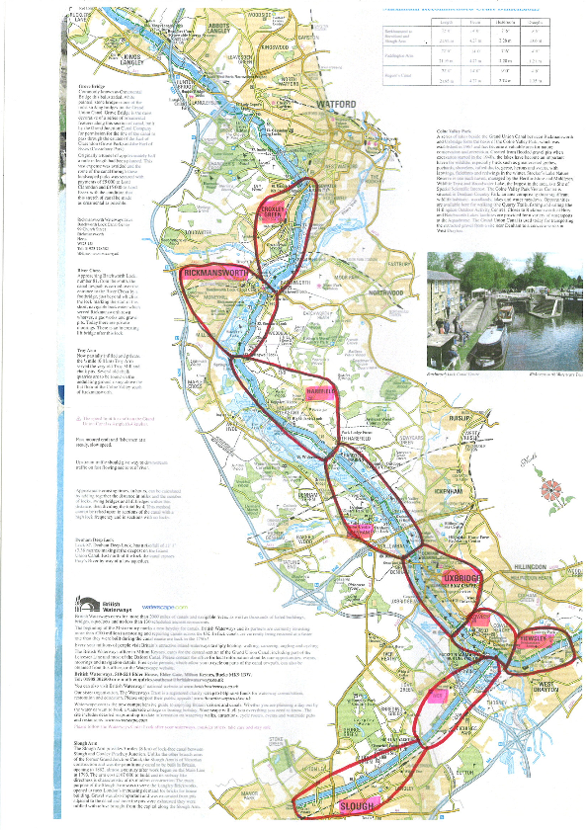
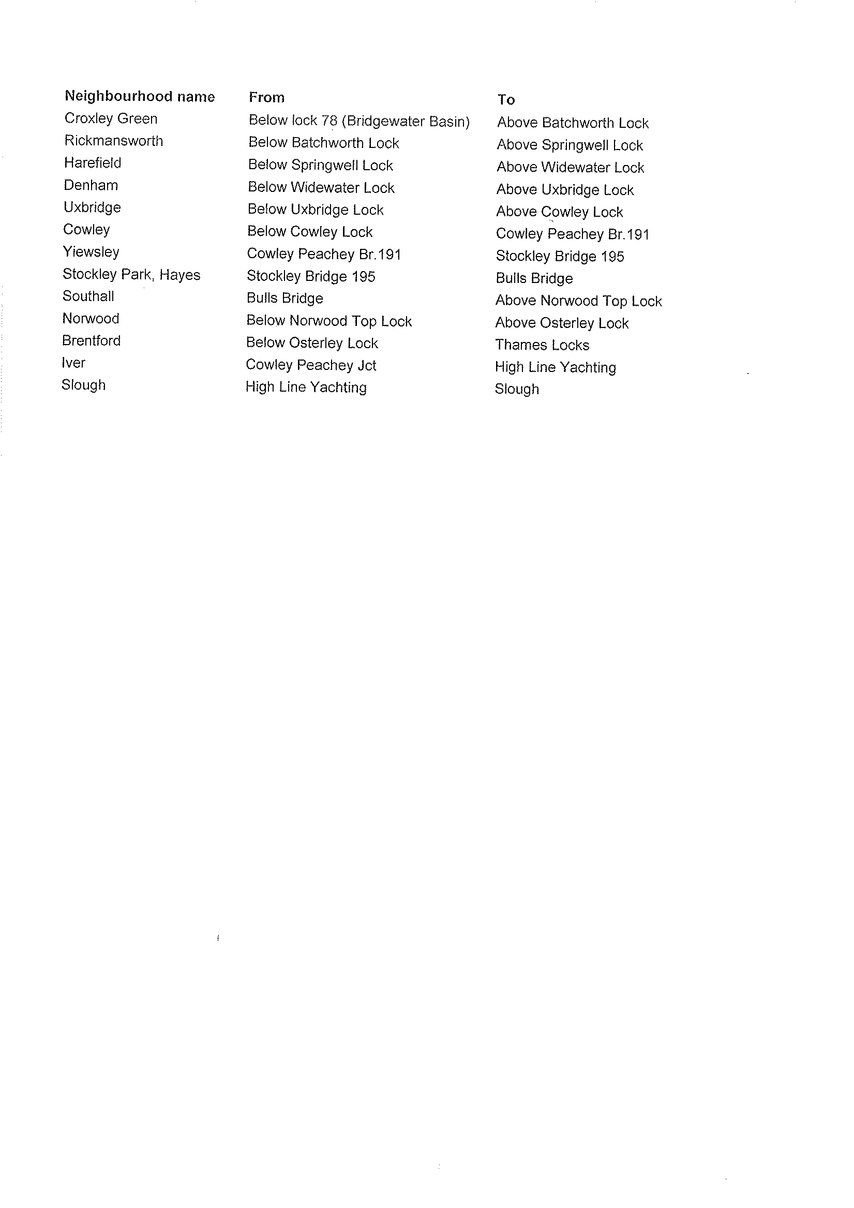
APPENDIX VI

Waterways Chaplaincy

Meeting with Hillingdon Council – 16th April 2013

Continuous Cruisers
The Council will pay housing benefit for continuous cruisers if your level of income meets the Government’s criteria but you must be within the Hillingdon area. Denham is just outside the area so if you are going to apply make sure you are within their boundaries. I pointed out that most continuous cruisers stay within the boundaries anyway and it was usually continuous cruisers with money that went further afield.

They have a different system which I think explains where the problems come. Any new applicant has to have their "property" registered (including a boat) and that can only be done through the council tax office. They then assess the "property - including boat" for council tax (Band A usually for boats) and add the details to the database. Nobody else can add a new claimant to the database. This happens even though the boat does not have a permanent mooring. So, make sure you are within their boundaries and give them all the information you can think of. First of all you have to meet the low income criteria and you have to be in the right area. You also need to either be on Job Seekers’ allowance, ESA, DLA (soon to be PIP) or on low income employment. If you cannot prove your income (even non income) you cannot get housing benefit.

Resident moorings
The Council were not happy with boaters who ask for benefit to pay for a residential mooring and then do not use that mooring. They will be putting a process in place to rescind benefit for such cases in the future. When someone is seeking housing benefit for a permanent mooring they need to first contact the rent officer to ask for an assessment of what the council will be prepared to pay for that mooring. This assessment should be done within 48 hours. They were horrified at some of the silly prices that moorings have been going for and would not be prepared to pay sums such as £4K or £5K.

The Council mentioned that, strictly speaking, those on leisure moorings should not be using as permanent moorings but were letting it go and assessing them as on residential moorings.

They understood the postcode problem but recommend that when someone is applying for benefit they should give all possible details and contact numbers so that when the council need to contact them they have a back-up and not just an address 30 or 40 miles away.

Applying for benefit for moorings or continuous cruiser licence
Although you can do a lot of this on line it is best to go into the office so that you can ask questions, a benefits adviser can ask questions and any queries can be dealt with there and then. Although the Benefits office is open from 9am to 5pm, the last appointment is usually 4pm. Do not try going to the Benefits Office on a Monday – they are always swamped. Wednesday is the quietest day. Similarly, do not try and go on a Friday afternoon when the world and his wife suddenly realise they need to talk to someone about benefits. This also applies on a Bank Holiday weekend – do not go on the Tuesday. Always take any paperwork you have such as bank statements, national insurance number, CaRT invoices, proof of identity and information about your boat. It also helps everyone if you agree to have the benefit paid direct to CRT and your enforcement officer or moorings manager can provide those details.

Jenny Dibsdall
Senior Waterways Chaplain
07717 813682

