Report by the Upper Lee and Stort Boaters’ Association in response to British Waterways ‘Draft Mooring Management Plan for the River Lee, Stort and Hertford Union Canal.’

(L.Watson, A.Watson, N.Warner-Baker, G.Elliott, R.Payne, J.Clack, M.Lowe, S Edwards, S.Law, G. Thomas)
Index

- Introduction
- Benefits of Boating Communities
- Problems for Continuous Cruisers
- Objections to Proposals
- Facilities
- maintenance
- Congestion
- Environmental Impact
- User Group Meetings
- Code of Conduct
- Survey
- Legal Situation
- Alternative Proposals
- Conclusion

Introduction

This report has been prepared by the Upper Lee and Stort Boaters Association (ULSBA), in consultation with its members and other users of the Rivers Lee and Stort in this area. The report is intended to form part of our members’ response to British Waterways ‘draft Mooring Management Plan for the River Lee, Stort and Hertford Union Canal’ (the proposals), for submission on or before 09/05/2011. It is anticipated that our members will also submit responses based on their own personal situation and circumstances as part of the consultation process.

Whilst ULSBA was formed in response to the proposals and intends to provide a platform from which our members can voice their concerns about them, it is also our intention that live-aboard boaters and other river users in this area should have the opportunity to come together to discuss issues that affect their lives on and enjoyment of the rivers into the future. This will enable us to work together to provide an environment in which we can live as we choose, within the law, whilst working with others to create a spirit of harmony and cooperation.

For the purpose of this report, data has been gathered concerning only the area from Waltham Abbey in the South, to Hertford in the West and Bishop’s Stortford in the East i.e. The Upper Lee and Stort.

At the public consultation meeting on 01/03/2011 at Stanstead Abbotts Village Hall, ULSBA presented a statement which had been prepared on behalf of all its members and which set out our position in relation to the proposals. The Statement read as follows:

The proposals put forward in the ‘Draft Mooring Management Plan for the River Lee, Stort and Hertford union canal plus the Regent’s canal in stage 2 ’ are considered by us to be ineffective, unmanageable, unfair, unlawful and unenforceable; legally, practically and ethically. Implementation of the plan is a waste of our licence fees and does not provide a solution to any of the issues that British Waterways state they are aiming to address. In fact, they create problems for all users of the waterways, not just us.
There is a lack of transparency in British Waterways’ proposals and the manner in which they have been communicated to the public. The changes serve to benefit no one, from boaters on residential moorings, through to cruising club members, fishermen and towpath users. They directly contradict British Waterways’ own Environmental Policy and will divert our license fees away from legitimate purposes (such as maintaining locks and providing adequate river side facilities for all boaters) towards costly and man-hour intensive monitoring systems.
We would like to stress that we all understand the need for security during the period of the Olympics and would, therefore, be happy to agree to reasonable proposals for this period. Merging these security measures with long term policies that will affect the use of our rivers and their communities, makes using the Olympics as an excuse irrelevant. British Waterways needs to address this as a separate issue.
In our capacity as boaters and as an association of boaters in this region, we intend to submit our own report which will detail all of our objections and suggestions.
We require today that British Waterways provide information and assurances about how these submissions will be considered and to what extent they will engage in the consultation process. British Waterways must assure us that they will listen to us and engage with us in this process. They have made repeated references as to “when we bring this management plan into effect” despite the fact that this event is by no means certain and the details are as of yet unknown. We also require British Waterways to specify exactly under what authority they intend to implement these plans and more importantly what gives them the power to enforce their rules by way of penalty charges, without specific legal entitlement. If these are, as they suggest mooring fees and not penalty charges, why do they double simply by not booking them in advance?
Our final comment is to boaters on residential moorings and to other groups on the towpath. These measures serve no benefit to you. British Waterways is already spending your money and ours on facilitating these plans. This money would be better spent on enforcing the 14-day rule as the law currently allows, keeping our canal sides clear and clean and providing adequate facilities to boaters.
British Waterways are clearly neglecting their duties and contradicting their own Mission Statement and their Environmental Policy. British Waterways say they aim to make a sustainable, economic, social and environmental waterway. These changes threaten all of these.
In summary, therefore, we wish to make is absolutely clear that we are strongly opposed to the Draft Mooring Management Plan.

Over the past 2 months much research has been undertaken by ULSBA and information has been gathered in order to assess the extent of any issues in the region, together with the usefulness and likely impact of the proposals in addressing these. This report will set out the findings of that research and will seek to address some of the problems that have been identified. In essence, however, we would state at the outset that our position remains unchanged from the statement above. Although some areas for improvement have been identified, in particular with regard to building relationships with other users, we have been unable to identify any areas in which the proposals would achieve a desired outcome that could not be achieved by consistent enforcement of the British Waterways Act, as the law allows, together, we will suggest, with implementation of a code of conduct for our members to sign up to (a voluntary ‘boaters’ code’). This, we believe, would achieve accord with other user groups, an outcome desirable to us all. We have identified a number of areas in which the proposals would create more problems for all river users than they seek to solve.

Benefits of Live-aboard Boating Communities

Britain has a long history of boating communities and for more than 200 years families have lived and worked on the rivers in this area. The river system was not developed in order to provide leisure facilities for the wealthy.
Boating communities provide many benefits to local people and businesses. They also assist the managing authority by taking responsibility for some areas of the waterways, thereby releasing resources to be directed to other uses. Without communities of boaters in this area the waterways would be less appealing to other users for a number of reasons.

- Safety
Live-aboard boaters provide security and just as importantly a ‘feeling’ of security to other users, particularly lone female users such as joggers, cyclists and dog walkers. Many people have commented that they particularly use areas where live-aboard boaters are moored as they feel safer knowing people are there in what is often, by its nature, a remote and lonely area.

- Reporting of problems
Boaters are on-hand to alert the managing authority to problems such as damaged or obstructed locks, sudden drop in water levels i.e. breech of banks etc. This is of particular importance in the winter months when there are very few leisure users in evidence and problems would potentially escalate without the intervention of boat dwellers.

- Maintaining waterway
The movement of boats helps to keep the waterway clear of obstructions and navigable, again particularly in the winter.

- Clearing rubbish
Many boaters take responsibility for the particular stretch of river on which they are moored and will clear rubbish from the towpath and ensure that it is kept tidy. We do not wish to live in an area with litter, dog waste and rubbish left around and will often remove items such as plastic bottles and carrier bags from the river itself.

- Tourist attraction
Narrow boats provide a picturesque river scene and an attraction for tourists and visitors to the area. Many visitors comment that they particularly like coming to the rivers to see the boats. This can be demonstrated by visiting any lock in summer, which will always attract many spectators.

- Licence fee revenue
Boat licences provide by far the largest portion of income for the managing authority in comparison to other river users.

- On-hand experts to help other boaters
Boat dwellers are generally a friendly group and will often help other users that may get into difficulty with, for example, using a lock, mooring up, steering their hire boat. Leisure users are often novice river users and benefit greatly from the friendly and helpful boat-dwellers that are always there to help out.

- Maintaining mooring areas by reducing overgrowth
Many areas of towpath previously used for mooring can become overgrown and un- usable. It is the continuous cruisers that often take responsibility for removing the overgrowth and returning the area to its previous state.

- Boaters provide an income to local businesses
Boaters need to use shops and businesses in the same way as the rest of the community. Continuous cruisers provide a steady income in areas that might otherwise be underused at off-peak or out of season times.
- Community Spirit
Boat dwellers are preserving a community spirit which has been lost in many other areas of society.

- Live-aboard boaters are more environmentally aware
As a group we are more environmentally conscious than other river users. We are likely to have a much lower carbon footprint as we limit the use of electricity, which is in any case derived from sources other than the national grid e.g. solar power, burning wood (which is carbon-neutral) and wind power. We are more aware of water conservation since we have a limited supply on a daily basis. We are more likely to be aware of and show respect for the natural environment since we live permanently in it.

Problems for Live-aboard Continuous Cruisers

Continuous cruisers live on the river all year round and the river and its immediate environment is our home. We too have issues with other people using the rivers and the impact that they often have on our lives. We also share some common ground with the managing authority and would like to see enforcement, in accordance with the law, which would alleviate some of the problems.

- There are increasing numbers of apparently unoccupied and often unlicensed boats left for significantly more than 14 days at popular moorings. These boats should be targeted by the managing authority as they create a nuisance and give other boaters a bad name.
- Lack of infrastructure and facilities, especially on the Upper Lee, an area which would become many times busier under the proposed mooring plan. We have provided a breakdown of facilities in this area in the next section.
- Fieldes Weir is the only British Waterways Elsan facility on the Upper Lee, north of the M25, despite the fact that there is a mains sewer running along the line of the Lee, meaning that the addition of other facilities would be inexpensive and easy to arrange. The facility at Hazelmere Marina has been out of action for some time now.
- Fast cyclists and especially motorbikes and quad bikes on the towpath are an increasing hazard to walkers, joggers and boaters alike. Action needs to be taken to avoid serious accidents.
- British Waterways does not appear to empty bins at weekends when they are most used and there are very few bins for boaters’ use. This results in rubbish piling up beside bins and accumulating in areas where there are no bins at all. The managing authority needs to act to remedy this situation which is not caused by live-aboard boaters.
- Some (a small minority) of continuous cruisers do not move nearly enough. This is the responsibility of the managing authority that already has the power to enforce the law and remedy this situation but chooses not to. We are a diverse group and the majority who are law-abiding object to being grouped together with those who are not, simply because they have purchased the same type of licence.
- Trees being cut down, seemingly for no reason and disposed of to landfill. This is wasteful and short –sighted and should not be allowed to continue.
- Fishermen casting with weights under boats (lead hitting paintwork under the waterline causes damage). Many fisherman deliberately fish close to boats as, we are told, the boats provide shelter for the fish. Fishermen are welcome to do so, but should remember that the boat is somebody’s home and should treat it with respect.
- Canoeists are not aware of how much movement they cause to moored boats and therefore do not slow down when passing moored boats as they should.
- Fishing line and litter left causing hazard to wildlife (dead kingfisher found tangled in fishing line at Tumbling Bay for example)
- Towpaths and rivers being used as fly-tips by walkers, picnickers and cruising boats. Live-aboard boaters often dispose of this rubbish as they generally wish to live in a clean area. However, it is the responsibility of the managing authority to use powers available to it under fly-tipping legislation to prosecute the perpetrators.
- Lack of movement of boats by pubs and ‘honey pot’ sites. Live-aboard boaters often prefer to moor in more rural parts. On occasion, however, it is necessary to be closer to towns and facilities. These are rarely available as some boats choose to overstay on these moorings. This is the responsibility of the managing authority to ensure that boats move every 14 days in accordance with the law, regardless of the type of boat.
- Dog waste on towpath
- Dog waste tied in bags and left all around due to lack of bins
- Cruisers going too fast and causing a hazard to other users and environmental damage.
- Drunk/drinking drivers of hire boats causing a hazard to other users. Inexperienced hire boaters crashing into moored boats.
- Lack of useable alternative towpath moorings, currently not available due to lack of dredging
- Lack of permanent residential moorings allowing boaters the lifestyle of their choice. Many continuous cruisers might take up moorings if they were available and reasonably priced.
- Litter

ULSBA Objections to the proposals

- We understand and believe that the proposals are unlawful and that enforcement of these ‘guidelines’ would be outside the powers of the managing authority and, therefore, illegal.
- According to Sally Ash, the proposals were not based on any research that has been undertaken and came from a combination of ‘pictures that you build up’ from ‘informal approaches’ and the results of the national consultation in 2009/2010, which she has now conceded did not represent the views of continuous cruisers. (Meeting 18/03/2011, Sally Ash )
- The Mooring plan does not differentiate between the winter and summer periods, which are entirely different with different sets of problems and issues needing to be addressed. Due to the timing of the consultation, our research has been based upon data gathering during the winter/spring period, which will be entirely different from the summer. The problems in the summer, therefore, stem from the huge influx of summer visitors, hire boats and leisure cruisers that are not present in the winter. It is unfair to blame continuous cruisers for numerous problems that do not exist when only they are present.
- Forcing all live-aboards to move twice as often at weekends in peak season is unrealistic and ill-conceived.
- The proposed vast neighbourhoods would cause excessive and unnecessary movement of boats, whilst not resolving any of the issues identified.
- Loss of water from upper reaches of the Lee and Stort as a result of boat movement; the rivers will be un-navigable and will run dry in summer
- Damage to the environment such as erosion of river banks and effects on marginal flora and fauna, again caused by movement of boats for the sake of bureaucracy
- Increased CO2 production
- The resulting huge increase in congestion is likely to cause friction with other user groups
- Many of the locks in this area are extremely old and the resulting increase in their use due to unnecessary movement would add to existing wear and tear and necessitate much more frequent monitoring and maintenance.
- British Waterways have consistently failed to take necessary enforcement action and have directly created all of the problems that they are now seeking to address. There is no confidence whatsoever in the assertion that British Waterways would be able to effectively manage the new proposals without huge investment and infrastructure. This is a waste of our licence fees and government funding. If it is the intention that penalty charges under the mooring plan will pay for this system, then that is confirmation of the suspicion that this is regulation for its own sake.
- British Waterways own income and cost projections show that implementation of their proposals would create a deficit of £3,250 per annum.
- Lack of recognition of live-aboard boaters as a significant user group that contribute to the waterways. The incorrect assumption that we are all the same can only be described as prejudice.
- Forcing boaters to moor in areas where crime and vandalism are more of a certainty rather than a possibility
- Unfair bias in the Mooring plan toward other user groups that use the river simply for leisure, even though continuous cruiser pay license fees and therefore make a larger contribution towards the maintenance of the waterways system than other users (assuming this revenue is correctly used).
- Overstay charges are excessive at £14,040 per annum if not booked in advance. Even if booked in advance, charges are excessive and disproportionate to the benefits offered by a towpath mooring
- Lack of residential moorings in the areas in which we wish to live have limited our choices and forced many people to cruise continuously even if they would rather not.
- The problems leading to the mooring plan could all have been avoided had British Waterways enforced the British Waterways act with the regard to the 14 day stay in the first place and not actively encouraged live-aboard boaters to overstay on the Lee and Stort
- There is a general lack of consideration given to issues such as illness, disability, accessibility to hospitals, doctors and dentists, voting, education of boaters’ children and proximity to place of work. Many people have lived on their boats for many years, often since before these became an issue in their own lives. ULSBA do not believe that it is fair to be forced to give up your home when any of these issues occur.
- There are no facilities for disabled and elderly users. Since continuous cruisers would all be forced to travel to unfamiliar places, the elderly and disabled among us would have to rely on strangers for assistance rather than their own community of friends and family.
- People with permanent moorings in other areas would not be able to ‘return regularly to their mooring’ if they are travelling long distances.
- Many boaters have experienced periods, some for several weeks, of being ‘iced-in’ during the winter and are therefore unable to continue their prescribed journey.

Facilities

The mooring plan, in its current form, would greatly increase boat movement, together with the number of boats in the Upper Lee and Stort area. Even in the winter the facilities, which are not adequate, would be unable to cope with the vast increase in boat numbers in this area that would result. Facilities currently in operation on the Rivers Lee and Stort north of Waltham Abbey are as follows:
River Lee:
Name Facility Operator
Broxbourne: Water point and pump-out. Broxbourne Hire.
Fieldes Weir: Elsan disposal and water point. British Waterways
Stanstead Abbotts: Elsan, pump-out and water Lea Valley R P A
S. Abbotts Lock: Water point only. British Waterways
Tumbling Bay, Ware. Facilities closed British Waterways
Hertford Basin: Elsan and water point. Refuse. Lea Valley Narrowboats Ltd.
River Stort:
Name Facility Operator
Roydon: Water £1 a tank full Owner of lock cottage.
Harlow: Elsan, pump-out, water, showers, refuse
(above burnt mill lock) British Waterways
Harlow:
(above Harlow Mill lock) Water point only British Waterways
Bishops Stortford: Elsan and water point British Waterways
It is apparent from our research that many boats often choose to moor close to facilities. This would appear to be the case for both continuous cruisers and leisure boats alike. Hotspots tend to exist close to facilities for example on the Stort, the Moorhen Pub which is by Burnt Mill is always busy and boats are often double moored. This is the same at Stanstead Abbotts and Hertford on the River Lee. The facilities in these areas in particular would certainly not be able to cope with the increase in boat numbers the mooring plan will create.

We recommend that BW improves and increases its number of facilities in the Upper Lee and Stort region.

In particular, there is clearly a lack of waste disposal sites. All boaters have difficulty disposing of their waste. This was clearly evidenced during the recent Bank Holiday weekend when rubbish was seen to be deposited by passing weekend boaters at the Elsan and water point at Feilde’s weir and at several other locations. This build up of rubbish is both unsightly and a health hazard, attracting vermin that scatter the remains of barbeques over the towpath. It is left to those that live on the river and regularly use these facilities to clear up. Rubbish was also seen deposited in trees and bushes on the non-towpath side of the river, where it had landed after being thrown from passing boats over the Bank Holiday. This was evidenced in several locations such as Dobb’s Weir. It must be highlighted here, that this is not the actions of a live-aboard boater.

There is issue, given the IWA draft response to the proposals, with boaters parking their cars in the few locations that they can do so without incurring heavy charges or inconveniencing local residents. The fact that live-aboard boaters frequently drive their domestic rubbish and recyclables to local tips, means that if BW target car users as a means of discouraging them to moor on large sections of waterway, they will be creating an even larger problem that is already in evidence when it comes to the disposal of rubbish.

This report recommends that a more proactive measure be taken through the establishment of frequent rubbish disposal and recycling points along the Upper Lee and Stort. In addition, since parking is an issue for all users of the river, it suggests that more parking sites be designated with areas explicitly set aside for boaters with BW keys.

Dog waste is a problem everywhere along the towpath and there is a serious lack of dog waste disposal bins. Again, especially in consideration of DEFRA’s predictions on the increase in leisure users over coming years, we recommend that dog waste bins are provided at regular intervals and particularly in areas of heavy use, along the towpath.

The closure of the elsan facility at Tumbling Bay in Ware, and the refusal to boaters’ applications for vacant BW long-term moorings that have been allowed to fall in to disrepair, demonstrates that BW have actually reduced facilities and available moorings rather than increased and improved the facilities (as recommended by the Lee Valley Park Authority in the Lee Valley Regional Park Plan 2000) in the Upper Lee and Stort region.

We recommend that BW re-open the Tumbling Bay Elsan point and consider re-furbishing and letting the moorings south of the bridge that have fallen in to disrepair. This applies also to a number of un-used moorings just north of Dobb’s Weir.

N.B. Several reasons have been given by BW for the closure of this facility. Namely, that the facility was only for use of the residents on the three available long term moorings and that complaints had been received over the misuse of the facility. However, more recently, it has become apparent that BW are preparing to sell the property in which the elsan point is found, with or without moorings. They have consistently sold off other waterways assets ie most of the lock houses along the Upper Lee. We would question the wisdom of these sales, particularly as they will then be lost as any form of waterways asset to the new waterways charity for ever. Again, this conflicts with the Lee Valley Regional Plan 2000 which recommends that waterways buildings are preserved.

‘Refurbished buildings can provide infrastructure for boating and leisure
industries whilst contributing to the economic and environmental
revitalisation of the corridor.’(p. 26 Lee Valley Regional Park Plan, 2000, Part Two, Proposals)

We recommend that BW does not sell off any more waterways buildings, moorings, infrastructure or facilities in this region.

BW have repeatedly argued that if boaters are genuinely continuously cruising, they will come upon these facilities frequently. However, whilst this may be the case, it is also the case that boaters who continuously cruise, frequently choose to stay in a place for a period close to 14 days as they are entitled to do by law. It is expensive, unnatural and environmentally unfriendly for any boater to be moving around the system on a near daily basis. The limitation on the number and frequency of facilities is perhaps the single most limiting factor to the movement and location of boats. If BW creates a system of more frequent facilities such as Elsan points, boats will naturally be more dispersed along the system rather than creating a perception of congestion.

Maintenance
It has already been stated that movement of boats within seven day time periods as opposed to fourteen day periods is going to increase the use of lock gates by up to double. However, considering the distances boats would be required to move through the imposition of ‘neighbourhoods’ to the size outlined in the mooring plan, this will increase lock use by considerably more than twice the use, perhaps more than four times the amount.

The Hydraulic operation of the lock gates at Burnt Mill Lock Harlow was introduced some years ago to replace perfectly operating manual gates. Two years ago the lock was closed for several weeks in the peak summer season resulting in much disruption and delays. Hertford Lock has suffered repeated failure of the paddle gear and was closed for several weeks last summer. It is difficult to envisage how much worse these situations would have been under the mooring plan.

There are a number of objections to the mooring plan in terms of maintenance. Namely:

- Since all boats on the system will be required to move every 7 days and to navigate the entire system in a sequential manner, a single lock closure or other maintenance issue will disrupt the entire region and will cause chaos.
- Locks will require much more maintenance than they currently receive to remain in good service, an added cost to British Waterways.
- Locks will be closed for maintenance more frequently than they currently are: most lock closures are programmed for the winter when boat movements are less.
- Locks may require closure during the summer months, which will severely hamper movement of all boats along the river.
- The proposals as they stand will create major disruption and actually reduce the movement of boats due to the requirement for lock maintenance (among other things).
- Since British Waterways has stated they have not made any thorough assessment of the impacts of larger boat movements through the lock system, we suggest they undertake a thorough assessment of the current state of individual locks, since many of the locks are very old. Assessment should be made of their maintenance requirements and any future maintenance programmes that will be required to ensure they remain in good service.
- BW rely on boaters informing them of many maintenance issues, much of which comes from continuous cruisers who often have some level of expertise and can relay the issues accurately and before major problems occur. It is important not to lose the goodwill of this group.

We recommend that a thorough assessment be made of the impact on the lock system before any mooring plan requiring boats to move more frequently than the law demands, comes in to effect.

Although the mooring plan is aimed at continuous cruisers, it states that any guidelines resulting from the consultation will also apply to boats with home moorings, who must return ‘regularly’ to their mooring. What ‘regularly’ entails remains unclear. This will have a major bearing on number of movements and increase use of locks many times over. Our members are keen to know whether British Waterways intend to refund all or part of our licence fees, should our journeys be delayed or disrupted due to increased maintenance issues or the mooring plan in general, along the lines of the railway operators’ policies currently in place?

Congestion

One of the main problems identified in British Waterways’ Mooring Plan is the belief that ‘the use in the plan area has become unbalanced to the detriment of many users’ and that ‘there are high concentrations of boats moored along the towpaths and they are increasing’. The Association felt that congestion was not a problem in this particular area but the need for data to support or deny this assertion was apparent. In view of this a study was undertaken which provided a ‘snapshot’ of the situation in the Upper Lee and Stort area in particular.

The data from the study undertaken by the ULSBA was collected over a period of a week from the 4th April. All boats along the towpath were counted and registration numbers were taken where possible to avoid counting boats twice through boat movement. An assessment was made as to whether the boat was a live-aboard or not and data was collected on the type of boat and whether a valid BW licence was visible. If no licence was visible or the licence was out of date, the vessel was counted as unlicenced. This does not, however, mean that the vessel was necessarily unlicenced as there are a number of reasons for not displaying a licence that is beyond the scope of this survey. In addition, data was collected on the availability and usage of visitor moorings through the area of the survey. The survey area representing the Upper Lee and Stort was divided into the following sections:

River Lee
- M25 bridge to Cheshunt Lock
- Cheshunt Lock to Carthegena Lock
- Carthegena Lock to Feilde’s Weir Lock
- Feilde’s Weir Lock to Stanstead Lock
- Stanstead Lock to Ware Lock
- Ware Lock to Hertford Terminus

River Stort
- Lower Lock to Sawbridgeworth Lock
- Sawbridgeworth Lock to Terminus

Area | Number | Type | Valid Licence displayed | Liveaboards
M25 bridge – Cheshunt Lock | 11 | 9 narrowboats  1 widebeam  1 cruiser | 7 | 7
Cheshunt Lock – Carthegena Lock | 27 | 21 narrowboats  6 widebeams | 27 | 24
Carthegena Lock – Feilde’s Weir | 4 | 1 narrowboat  3 cruisers | 1 | 2
Feilde’s Weir – Stanstead Lock | 9 | 7 narrowboats  2 cruisers | 2 | 7
Stanstead Lock – Ware Lock | 19 | 15 narrowboats  1 widebeam  1 Dutch Barge  2 BW workboats | 14 | 12
Ware Lock – Terminus | 14 | 11 narrowboats  3 cruisers | 13 | 9
Lower Lock – Sawbridgeworth Lock | 38 | 27 narrowboats  9 widebeams  2 cruisers | 27 | 24
Sawbridgeworth Lock to Terminus | 10 | 9 narrowboats  1 Dutch Barge | 10 | 7
Totals | 132 | 100 narrowboats  17 widebeams  11 cruisers  2 Dutch barges  2 BW workboats | 101 | 92

The data shows a total of 132 boats on approximately 26 miles of canal; an average density of 5 boats per mile of waterway. This comprised of 100 narrowboats, 17 widebeams, 11 cruisers, 2 Dutch barges and 2 British Waterways’ maintenance vessels. The majority of boats (70%) were assessed as live-aboards. Of the 132 boats, 101 (77%) had visibly displayed valid BW licences. Of some surprise was the fact that 2 of the boats with ‘out of date’ licences were owned by British Waterways, namely the two maintenance boats moored between Ware Lock and Stanstead Lock (Reg. Nos. 4000537 and 4000550). Throughout the survey area, visitor moorings were either clear of boats or had a number of spaces available for visiting boats. No boats were moored on lock landings. No location was deemed to be congested, although boats are generally found to moor in groups. Reasons given for doing so, as stated by ULSBA members include security (probably the most commonly cited reason) and proximity to road access, local shops and facilities such as water and Elsan points.

Unfortunately, due to time-constraints of the consultation period, it has not been possible to collect data on boat movement for the purposes of this report, which is an important area that needs to be researched fully, before a conclusion can be reached. However, were data to be collected in a longitudinal survey, it would likely show a considerable seasonal variation, perhaps indicating a large increase in boat movement of all types during the summer months, particularly those with moorings. In winter months the data would likely show very little movement of different types of boat with the exception of Continuous Cruisers who have not taken up ‘Winter Moorings’.

It is worth considering the likely effects of the current BW proposals on future boat movement and numbers. If boats are required to move larger distances between neighbourhoods and more frequently (every seven days) the influx of boats from more densely populated areas such as London will undoubtedly increase dramatically the overall number of boats on the Upper Lee and Stort and create congestion at both locks and visitor moorings. This would surely have the opposite effect than that which, ostensibly, the mooring plan is seeking.

It is recommended here, that a proper longitudinal survey be made over at least a year period to establish a pattern of movement of boats across this region before any actions affecting movement, which must be carefully considered, are taken.

Environmental Impact

At Feildes Weir where an average of 4.5 m3 per second is flowing over the weir, there is sufficient water to keep the 240m3 lock supplied in about one minute. But just around the corner on the Stort above Lower lock, problems occur with just the passage of a few boats. The pounds are easily emptied due to less water being available for the navigation. The same happens on the lower Lee and pounds. If the BW figure of 721 boats on the Lee were to be forced to move every seven days, these boaters would likely choose to do this at the weekend, which would result in a surge of movement of water through the locks and resulting problems. This would also wash a lot of young fish into the lower Lee where they would be lost to pollution.
The obligatory increase in movement may be inconvenient and may therefore tempt some boaters to attempt to complete their journey as quickly as possible. This would result in the following problems: Boaters increasing their speed, racing to locks that they think might be in their favour, overtaking to avoid queuing and so on. The extra speed would increase wash, adding to bank erosion and destroying bird nests and other wildlife and habitat.
Extra fuel would be burnt turning the below average carbon foot print of boaters, into a larger foot print. The prescribed cruising pattern resulting in the need to move quickly would result in less towing and less use of electric propulsion on hybrid boats. Higher prop speeds would result in more prop grease in the river. Boaters would have less time for engine maintenance, resulting in higher probability of pollution and hydrocarbon discharges from badly maintained boats into the river. Old industrial anthrogenic pollutants and bacteria in the silt would be stirred up and released directly to the fish. This would indirectly pollute the food chain for fish at the top of the food pyramid.
Mercury has been found in the Upper Lee and has remained in the bottom silt for over a century. Action should be taken to decrease the likelihood of this being disturbed, not increase it.

Although some areas and locks of the navigation might cope, others would fail since the distribution of water flow is not uniform due to the hydrological properties of the river flow in losses and gains in and out of the navigation channels. Some sections of the navigation would have empty pounds particularly where locks are close together caused by boats moving en masse in one direction, simply to move into a new sector and then stop. This is due to the fact that boats would not be moving slowly bringing water with them through the pounds in a single progressive journey. This has happened when boats have rallied at one point for a local event.

We recommend that a full hydrological survey be undertaken to assess the impact of the mooring plan on water levels and the impacts on flora and fauna in the Upper Lee and Stort, notably fish stocks, before any plan can be considered. We are advised, for example, that no such research was undertaken prior to the developments at Roydon Marina. This has lead to many problems that could have been avoided.

User group meetings

On 04/04/2011 the ULSBA organised a meeting for a diverse range of user groups of the Rivers Lee and Stort, to come together to discuss any perceived issues and identify actual problems that these varied groups may have in using the rivers in conjunction with each other.
We explained that The Upper Lee and Stort Boater's Association was formed in response to the Mooring Plan and that the purpose of the meeting was to liaise with other user groups of the rivers to discuss issues relating to continuous cruisers and how the current proposals will impact on us and others using the rivers. We stressed that it was our intention to develop a policy of our own, which will accommodate all of us and will include a code of conduct for cruising boaters, which will, hopefully, serve to diminish any issues and problems that other groups may have with continuous cruisers. It is our intention that the code of conduct will assist in creating a framework of use, to avoid any clashes in using parts of the river between all user groups.
We stated that we anticipated that a series of discussions would follow, that would allow us to make effective proposals and that we were keen to hear from as many interested parties as possible, regardless of their feelings toward continuous cruisers.
On that occasion, the following groups/associations were represented:
IWA (Area Representative)
NABO (Chairman)
RBOA (Vice-Chairman)
Stort Boat Club (Secretary & Representative)
Lee & Stort Cruising Club (Commodore & Vice-Commodore)
Broxbourne Cruising Club (Chairman)
Ware Anglers (Chairman)
Hartham Commoners Cycling Club (Chairman)
Upper Lee and Stort Boaters’ Association (Chairman & Committee Members)
London Boaters (Representatives).

We asked those in attendance to group together with similar associations in order to identify any issues that they have with either continuous cruisers or with the Mooring Plan.

- Representative Bodies -The Group of representative bodies (i.e. NABO, RBOA & IWA) made the following observations:

Problems are being vastly overstated by British Waterways
Lack of data to support claim of overcrowding or any other problems
Continuous Cruising is not realistically defined in the proposals
As a boater with a home mooring I never have a problem finding a mooring when cruising
Need to ensure the 14 day rule is observed
‘Honeypot’ / hotspot sites
IWA did think there was an issue with overcrowding and need to discourage more boats / reduce numbers
Mooring on lock landing stages
Waterways are for freight and Leisure, not for static communities (IWA)
Waterways are not suitable for a large number of ‘towpath boats’ although not an issue in this particular area (IWA)
Too many live aboard boaters is a bad thing, a few is a good thing, numbers need to be controlled and perhaps reduced (IWA)
Neighbourhoods are a step in the right direction, but so many boats cannot move off the Lee as the Grand Union is also congested (IWA)

They went on to offer the following suggestions for solving those issues that they had identified:
Moorings should be more readily available and affordable
Be flexible in the use of leisure moorings, possibly 4 -5 boats sharing a non residential leisure mooring? This would ensure people had a ‘home mooring’. Each boat could use it for a few weeks and not break ‘non residential’ rules
BW should create more 48 hour moorings at particular very limited hotspots
Create extra ‘open space’ moorings by dredging by banks
We should all work with BW to create more recognised 14 day mooring sites
Introduce a ‘double berthing’ or ‘breasting up’ policy, together with a window sign welcoming mooring alongside.

- Cruising Clubs - The Cruising Clubs stated that the following issues and problems were of note to them:

Towpath clutter and obstructions
Mooring on lock landings
‘Picnic site’ (Great Amwell) constantly occupied by ‘continuous moorers’
Lack of available useable places to moor that are not visitor moorings
Unlicensed boats

They also felt that the following issues with the Mooring Plan should be considered:

Impacts on water levels of increased movement
Increased traffic causing congestion and wear and tear at locks
Environmental damage
CO2 emissions
Inability to enforce quickly enough

They were able to offer the following suggestions:

More affordable moorings
Maintain more bank-side for visitor/cruiser moorings
Cruising clubs could issue calendar of social events to ULSBA so all are aware of areas in demand at certain times
BW need to undertake a hydration survey to understand impacts on water levels of any proposed new system
Automation of more weirs on River Stort
Upper Lee & Stort Group should have a website to enable sharing of information
Boaters should be self managing with code of practice (and possibly boaters adopt a sticker in the window e.g. ‘We Adopt the Code’ so others / British Waterways know who is seeking to abide by it)
On Lower Lee / London Canals cruising clubs find overcrowding a problem at Stonebridge and Victoria Park.
Springfield / Marshes / Filter Beds not a problem – these are not places the cruising clubs want to stay as there are concerns about safety in these areas.

- Other Groups and Associations - The other User Groups stated the following:

Problems
Cyclists have no issues with boaters
Anglers have no issues with boaters. In addition they are not aware of any cases where fishing matches has been disrupted by boats

Those among the group who were riverside residents stating that the following are occasionally a nuisance
Boaters cars parked in some residential areas inconsiderately
Engine and generator noise from boats – especially after 8pm
Issues with the proposals
- Anglers would have issues with increased movements of water through locks removing stocked fish from fishing areas
Solutions
- Code of conduct for boaters
It was suggested that this should be based on e.g. IWA Boaters Guide, Considerate Boaters Website.
Set of guidelines should be issued with licences

Code of Conduct

The idea of a ‘Boater’s Code’ has been unanimously approved by the ULSBA and other user groups that have been consulted. We have discussed various ideas for ensuring that all our members are aware of the code and how we would then make others aware of its existence. It is not our intention at this stage to produce a finished document, detailing all aspects of the code. Rather, this is a work in progress which will be refined and eventually, it is anticipated, will provide straight-forward, precise guidance that will enable all user groups to work together in harmony. Many of the main points so far are already in practice by our members. In addition, we have instigated the idea of sharing diaries between organizations to enable boaters to avoid particular areas planned as venues for other groups’ events and meetings. The code of conduct encompasses the ideas and issues brought to our attention at the user group meeting on 04/04/2011 and incorporates ideas from previous BW guidelines, together with the ideas from the website theconsiderateboater.com . It will include the following:

- be considerate and polite to all canal and towpath users.

- protect the waterway environment and take care not to harm or disturb wildlife.

- Observe British Waterways’ regulations and guidance (once agreed) and in particular British Waterways Act 1995, S17 (3) (c, ii)

- The speed limit on the Canal for all boats is 4mph (brisk walking pace).

- Always avoid mooring at Water points
Elsan points
Lock landings

- Avoid visitor moorings whenever possible, especially over weekends/ bank and school holiday periods

- Moor economically. Take up as little space as you can. Be prepared to move to make room for boats ahead of and behind you.

- Allow craft with elderly people or young children to moor against visitor moorings and be willing to move off to allow them to do so

- be prepared to moor alongside others and encourage others to moor alongside you. Always ask permission before coming alongside and make sure your boat is well fendered

- Mooring is always prohibited in winding holes (turning points) and within10m of bridges

- When mooring on the towpath, do not tie lines across the towpath and ensure mooring pins are protected or easily visible.

- If possible, vacate visitor moorings and ‘honeypot’ sites before they become busy

- Litter/ rubbish/eyesore:. Be proactive in removing rubbish from the towpath

- Noise: be aware of other river users and keep noise levels low
Acceptable engine/generator running between 8am-8pm

- dog owners: keep dogs under control and always clear dog mess

- Anglers: Most anglers prefer boaters to proceed past in the centre of the canal channel at a steady speed, unless they request otherwise. Please look out for anglers as they may sometimes be obscured

- Wildlife: Please minimise disturbance to wildlife by keeping to the central canal channel and slowing down when passing wildfowl – especially when they have young with them. Many birds nest in the reeds along the edge of the river so please take particular care during the nesting season (spring and early summer).

- Whilst cruising : Be calm and well mannered
observe BW regulations (once agreed)
Ensure Crafts’ Wake(wave) does not hit bank to reduce river erosion

- Crime prevention Look out for other river users and report incidents

Survey

The Upper Lee and Sort Boater Association Riverside Survey April 2011

A survey was undertaken along the towpath of the River Lee and River Stort from April 4th until April 24th 2011.
The need for such a survey arose from the initial British Waterways consultation at Stanstead Abbotts where British Waterways’ representatives repeatedly stated that there had been complaints about live-aboard boaters. This gave the impression that the live-aboard boating community creates problems for other users. No substantive or quantitative data was offered by British Waterways who at a later meeting actually confirmed that none was available as no research had been done. They did, however, cite a 40% increase in all boats on these rivers.

The aim of the survey was to ask 5 very simple questions of other river users in order to examine attitudes toward live-aboard boaters with a view to identifying and finding solutions for any issues and problems that may exist. We also wished to test the idea that other river users dislike the local resident boating communities and consider them responsible for problems and issues as suggested by British Waterways, since this is certainly not our experience of their attitude toward us in general. We hoped that by providing data we would be able to demonstrate that no such problems exists, or that if they do they are with a minority of users and could be easily rectified.

The survey was left along the towpath for people to complete as they wished without influence or interference. A sample form is attached which shows that participants were able to choose from the following options: agree, disagree, state that they did not know or had no opinion. Samples of the ‘any other comments’ left can be viewed at the end of the results. The form also asks for a postcode, firstly to help validate the survey but which also gives a small mapping element to the results. In the large proportion of completed surveys people did leave a postcode.

Survey results

We received a total of 270 completed questionnaires. The breakdown of river users corresponds roughly to expectations (i.e. as per DEFRA consultation) and of the ‘other’ users most stated their use of the river as canoeists or runners.

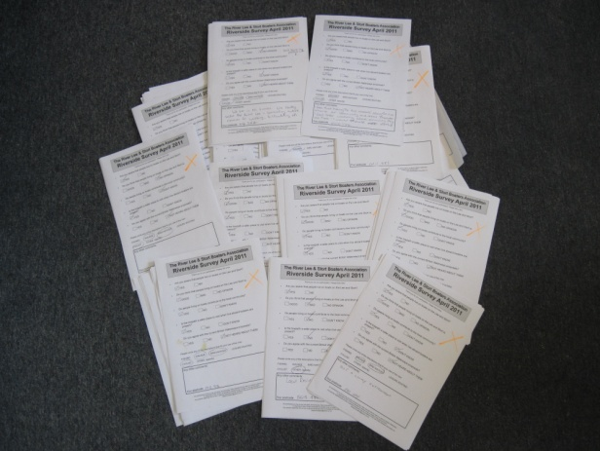

Question 1

Are you aware that people live on boats on the Rivers Lee and Stort?

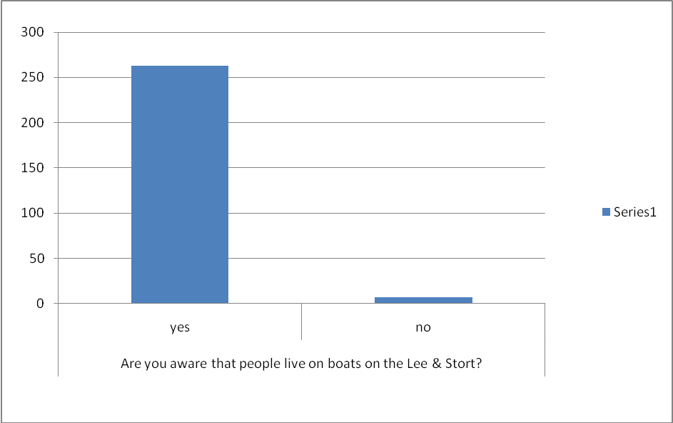

Question 2

Do you think people living on boats is (choose option; good, bad, no opinion)?
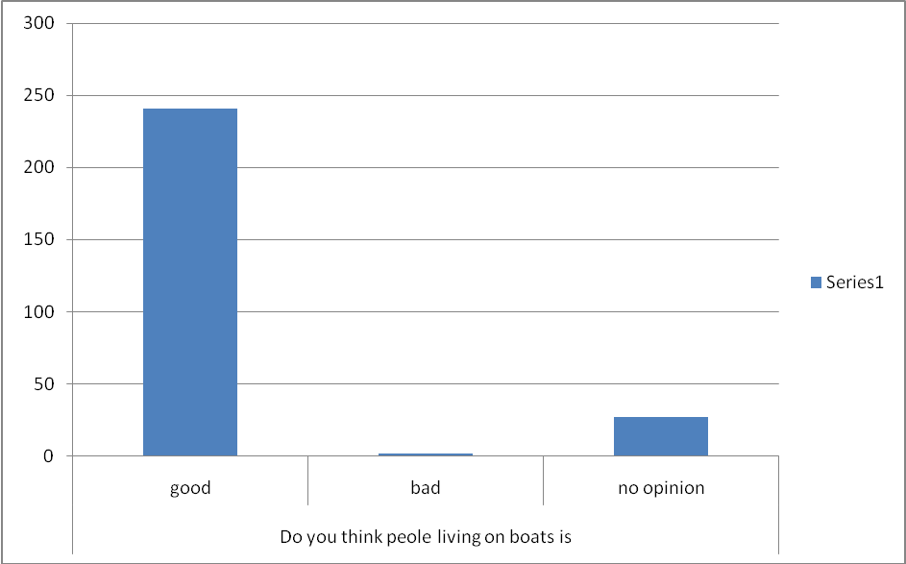

Question 3
Do people living on boats add to the local community?

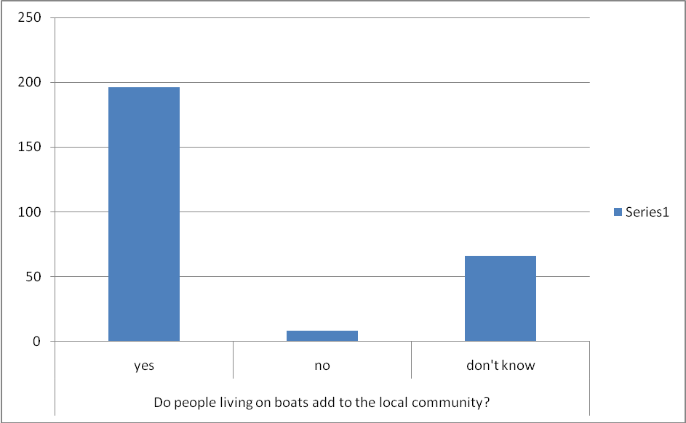

Question 4

Is the towpath a safer place to visit when live-aboard boaters are present?

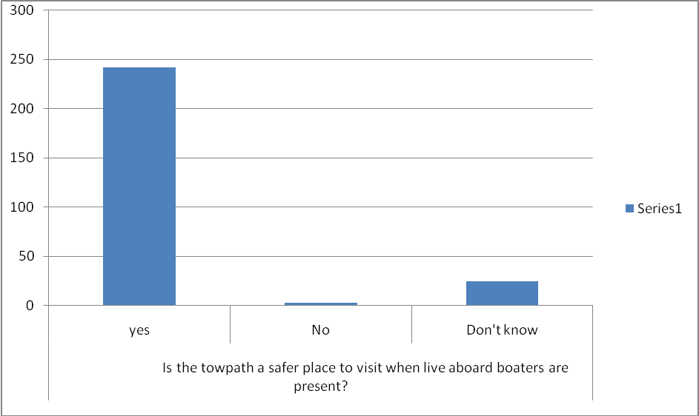

Question 5

Do you agree with the current British Waterways proposals?

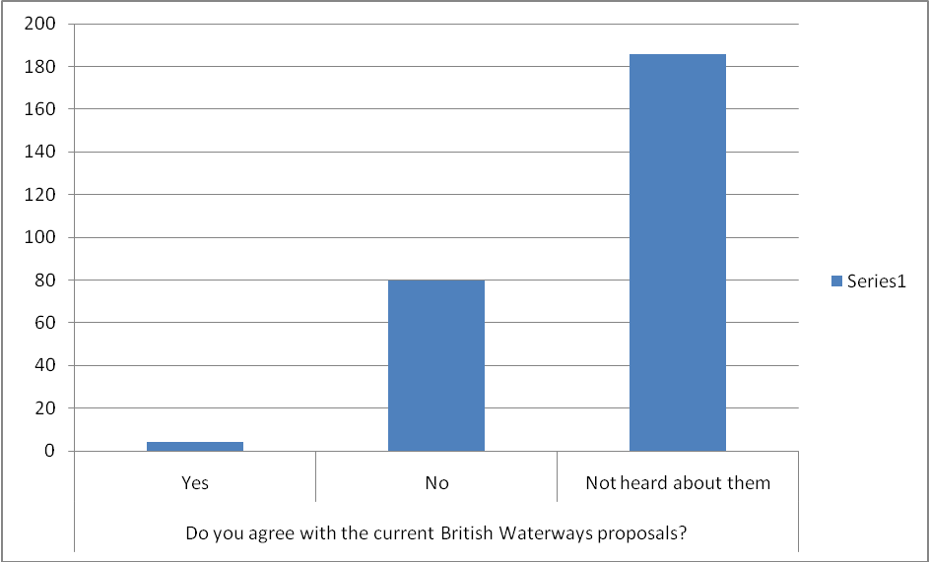

River usage represented in this survey
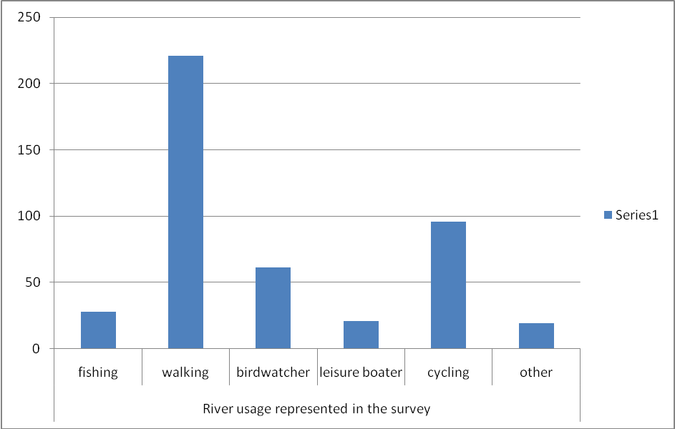

Any other comments

We feel that the most important section of the survey is the ‘any other comments’ section, giving participants the opportunity to comment as they see fit, having established the general subject area. It must be stressed that the survey forms were left unattended for passers by to complete if they wanted to. We felt this would enable people to participate freely without feeling under pressure to answer in any particular way and to avoid causing offence if they had issues they wished to report.

Most people did choose to comment further and almost all of the comments made were friendly and positive toward live-aboard boaters, with some taking the opportunity to criticize British Waterways with regard to unrelated issues.

Here is a selection of the comments made. All forms and raw data are available for inspection if required.

‘I think the boat dwelling people are some of the friendliest people in my community. They also definitely make the towpath a safer place for a woman like me to walk along (I only have a small dog).’
Walker, SG12 8AG

‘Not heard about the proposals, yet I visit the river often?’
Cyclist, kayak, runner, CM20 1TW

‘Boats are an essential part of the river scene both historically and the present day. Am against any plan that would make people who live on boats driven away from the area’
Dog walker, SG12 7BD

‘I’ve been cycling everyday from Hertford to Hoddesdon for 15yrs and have made lots of friends with boat livers. Without them it would be like a desert.’
Cyclist, EN11 9JE

‘I feel that having the live-aboards along the river enhances our community and creates character. I feel safer walking along knowing they are there – I wouldn’t do this otherwise’
Walker, cyclist, EN10 7JG

‘You feel safer when walking down the river knowing that there are river residents nearby. In case of emergency or worry about being followed by whoever.’
Fisher, walker, birdwatcher, cyclist, CM20 3DA

‘BW seem to want to make the towpath as littered as possible. They need to provide more bins.’
Walker, SG12 7AP

‘Boaters usually add to interest of towpath and generally respect all users.’
Walker, cyclist, SG12 9XS

‘I’ve made many friends along the river’
Cyclist, CM18 6SN

‘I am not fully informed about the BW proposals. I will inform myself of the details. The live aboard boaters enrich our society, they are colourful and interesting addition to the life of our community.’
Walker, CM20 3DN

‘Our rivers should be thriving places so communities of people living on the river should be welcomed.’
Walker, CM18 6RR

‘Makes a more attractive environment. Safer if walking alone.’
Walker, EN5 2XA

‘Stable boat-dwelling community is a major environmental advantage. Lived in sections of towpath are much cleaner, better kept, tidier than sections unoccupied.’
Cyclist, SG13 7JR

‘I think the local river-way is a much better place with regular live aboard boaters. Is a much tidier and safer place to walk.’
Walker, SG12 8LH

‘It is important to respect the rights of the stable boat community. They help to protect the environment and protect the users of the canal.’
Cyclist, E4 7LY

‘We feel that there’s a benefit to everyone and boaters are a pleasant attraction for other users. It’s a friendly and good community that benefits all.’
Fisherman, walker, bird watcher, leisure boater, cyclist, EN6 4AN

‘Cyclists have no consideration for other towpath users.’
Walker, leisure boater, SG12 8EE

‘I run down the river often and feel safer knowing people live along the river.’
Walker, runner, SS8 7DE

‘As a regular lone female cyclist between Hertford and Dobbs Weir I rely on canal boat owners presence in case of emergency and for my safety.’
Cyclist, SG13 7JR

‘I think that people that live on boats contribute to the local community and should be left alone.’
Walker, cyclist, CM20 1RP

‘I walk along the towpath every day with my dog, morning and lunchtimes. As a lone woman it can be quite daunting if there is no one around so to see people on their boats makes me feel a lot safer. I have made many friends along the towpath, most of them boat dwellers and would miss them if they were not there.’
Walker, EN10 6HX

‘Leave the boat people alone. They’re great and we love to see them and have a chat’
Fisher, walker, bird watcher, cyclist, SG12 9TE

‘I am totally disgusted with the waterways cutting down ALL the trees and shrubs along the riverbank.’
Bird watcher, AL7 3LL

‘If you force these residents out of their homes where will they live?? Councils and taxpayers will yet again be responsible for housing people you have made homeless by increasing rates and making it impossible for them to live in one area. The residents of the boats are an addition to the community! They make the towpath safer and keep it clean!’
Walker, cyclist, local resident live next to river, SG12 8EE

‘It’s good knowing local boaters rather than strange boaters because I feel safe with my Grandchildren when using the walks.’ J Rowe, leisure boater, SS16 5TQ

Legal Situation

British Waterways (Sally Ash) has consistently described a licence granted under section 17(3)(c ii) – ‘a continuous cruiser’- as an ‘exception’ being granted. This is quite clearly not the case and is simply one of two options as is evidenced by use of the terms ‘either’ and ‘or’ in the following extract. It would appear that British Waterways are attempting to create the illusion that the second type of licence is in some way inferior to the first, or is granted as a favour to the applicant. This is not the case. They are obliged to grant the licence in both circumstances by law. Both carry the same weight and are equally valid.
:

- The British Waterways Act 1995 s.17 (3) ‘Conditions as to certificates and Licences’ states that

Notwithstanding anything in any enactment but subject to subsection (7) below, the Board may refuse a relevant consent in respect of any vessel unless—
a)the applicant for the relevant consent satisfies the Board that the vessel complies with the standards applicable to that vessel;
(b)an insurance policy is in force in respect of the vessel and a copy of the policy, or evidence that it exists and is in force, has been produced to the Board; and
(c)either—

(i)the Board are satisfied that a mooring or other place where the vessel can reasonably be kept and may lawfully be left will be available for the vessel, whether on an inland waterway or elsewhere; or

(ii)the applicant for the relevant consent satisfies the Board that the vessel to which the application relates will be used bona fide for navigation throughout the period for which the consent is valid without remaining continuously in any one place for more than 14 days or such longer period as is reasonable in the circumstances.

This clearly states that ‘Bona fide navigation’ entails not staying in any one place for more than 14 days unless there are circumstances that prevent moving. British Waterways’ interpretation suggests that a ‘place’ is an area of several miles. This is quite clearly not the case and is misleading, confusing, unnecessary and self-serving. Ask any reasonable person to define ‘place’ and you would hear answers such as ‘my house’, ‘a town’, ‘a village’ ‘a district’ or ‘a certain landmark’. You would certainly not hear ‘anywhere between Hertford and Hoddesdon’ for example. It would be extremely difficult to pin-point that place for any purpose.
It is evident that British Waterways ‘Mooring Guidance for Continuous Cruisers’ contains an unlawful definition of the term "used bona fide for navigation", since the law clearly states that this is determined by whether a boat has remained continuously in one place for longer than 14 days without a valid reason (House of Commons Select Committee on the Waterways Bill, 1993-94).

On 18/03/2011, Sally Ash, Head of Boating at British Waterways, stated that the people at the public consultations were ‘people who have made lifestyle decisions on the basis of a set of assumptions which don’t actually tally with what the law prescribes’. The law prescribes only that a boat does not remain in any one place for more than 14 days without a valid reason, it is, therefore, apparent that the mooring plan can only be concerned with those boaters who do not move often enough or at all.

British Waterways' power to set mooring restrictions of less than 14 days and to erect notices or signs designating mooring restrictions of less than 14 days are limited to the power to set advisory restrictions and erect advisory notices or signs. (House of Commons Select Committee on the Waterways Bill, 1993-94). It is apparent that they do not have the power to make charges for exceeding a mooring time limit that is advisory only.

Further, British Waterways does not have the power to impose fines for contravention of mooring time limits and/ or mooring restrictions (House of Commons Select Committee on the Waterways Bill, 1993-94). Use of the descriptive term mooring "charges" in the mooring plan, is intended to avoid this issue by claiming these are not punitive or penalty charges, rather that they are genuine charges for a towpath mooring. Unfortunately, this argument is invalid since the level of the proposed charges far exceeds the stated average annual mooring fee of £1,500 to £2,000.

In summary, British Waterways only has the power to prevent boats without moorings from staying continuously in one place for more than 14 days and only when there is no valid reason for a longer stay. They do not have the power to prescribe cruising patterns for boats without moorings or to set restrictions on return to particular places (House of Commons Select Committee on the Waterways Bill, 1993-94).

Alternative Proposals

On the Upper Lee and Stort, as we have shown, there are no problems with congestion (an average of 5 boats per mile) and as evidenced by the user groups meeting and discussions it is apparent that we are in the process of developing a good relationship with other users in this area. Despite much discussion and debate it is still unclear exactly what the issues and problems on the Rivers Lee and Stort are, although it is accepted that there are some areas where improvements could be made. Sally Ash actually stated on 18/03/2011 that the mooring plan stems from some informal approaches and a picture built up from discussion with some user groups that did not include continuous cruisers. She confirmed that no research has been undertaken at all to investigate the issues that those groups identified. Without firm evidence of the aims of the proposals it is a difficult task to attempt to suggest alternatives. What exactly needs to be achieved is unclear and many assumptions have had to be made.
ULSBA have identified many issues that affect their own members and have undertaken research to attempt to identify the problems that exist for all river users and for the managing authority with a view to looking for ways in which to solve them. It is widely believed that one main driving force behind the proposals is the need for British Waterways to increase revenue following the recent changes which have reduced their funding by a considerable sum.

Listed below are the main issues that we have been able to identify together with some suggestions that may, in combination, go some way to solving these issues.

- British Waterways need to generate revenue

The need to generate income is apparent and should come from a combination of sources, not just continuous cruisers. A significant amount of revenue is currently lost due to the number of unlicenced boats. This could be resolved by taking prompt and appropriate enforcement action. Other users should be considered and ideas like cycling passes have been put forward. Provision of facilities for boaters would be widely used and could, if managed correctly, produce a significant income. Many continuous cruisers would be prepared to pay for a winter mooring for the months of November to April if these were available, in a location of their choice at a reasonable price. British Waterways, once a charity, will have the opportunity to create income through marketing and by developing the underused properties along the waterways which could be information centres, youth accommodation or shops and facilities for towpath users. These properties are often derelict or sold and lost to the waterways which is against the vision for the Lee Valley Park.

- Some continuous cruisers do not move often enough or to a different place and are, therefore, breaking the law.

The British Waterways Act (as quoted above) does not include information on the distance required to be deemed to have moved ‘place’ and does not specify time limits for returning to a certain place. However, it is obvious and apparent when a boat does not move at all, or moves a very short distance and is still in the same place, in the commonly accepted meaning of the word. The law allows for such boats to be refused a licence. It may be possible to reach agreement for a definition of ‘place’ by considering reasonable solutions such as the accepted ‘2 lock’ distance, parish boundaries or 1km markers. This approach relies on both parties acting in a reasonable manner and the ambiguity should not be used as an excuse to overstay, or to refuse to licence a boat. The solution, therefore, is for British Waterways to take prompt enforcement action as the law allows and for boaters to follow whatever guidelines are eventually agreed.

- Some boats are unlicenced

The law is clear and BW has the power to remove unlicenced boats from the waterways. More vigorous enforcement action should be taken against boatyards who are prohibited by law from introducing unlicenced boats to the waterways.

- Visitor moorings and lock landings congested at times by some boats overstaying/mooring inconsiderately.

Enforcement action as described above would solve the problem of boats overstaying on visitor moorings. The ‘Boater’s Code’ would encourage those that were aware of it to moor considerately and choose their location more carefully, particularly at busy times.

- Insufficient short-stay visitor moorings

The ULSBA supports the introduction of time-limited visitor moorings and would encourage other boaters to moor away from these at busy times and to moor on the towpath whenever possible, particularly at weekends, bank holidays and during the summer season.

- Insufficient residential moorings

Many continuous cruisers may decide to take up a permanent residential mooring if such was available and reasonably priced. This would reduce the number of boats mooring on the towpath and give boaters the opportunity to choose such a mooring when their personal circumstances demand that they stay in one place for long periods of time.

- Large areas of towpath unable to be used for mooring due to lack of maintenance (dredging)

Better maintenance of the rivers would increase the amount of usable space for mooring and allow boats mooring on the towpath to spread out and moor in more remote areas if they wish. This would avoid possible congestion.

- Complaints from some leisure users. i.e. lack of consideration and communication between groups

ULSBA have initiated a dialogue with local user groups and have undertaken to attempt to ease any areas of conflict, possibly by introduction of the ‘Boater’s Code’ and by obvious markers stating ‘we follow the code’ displayed. A website is being constructed which will be available to local groups to post details of forthcoming events that may require continuous cruisers to avoid the area and plan their movements accordingly. The groups we have spoken to are enthusiastic about these ideas and are confident that we can work together to achieve this in this area.

- Lack of facilities, notably rubbish disposal/ recycling

The installation of regular facilities would encourage boaters to moor in different places and would avoid congestion at well-serviced locations. These could be accessible by BW key to prevent misuse. More rubbish disposal areas would encourage other users to follow the lead of the continuous cruisers and not dump their rubbish on the towpath.

Recommendations

  - Income should come from a combination of sources, not just continuous cruisers.

  - Prompt enforcement action should be taken against unlicenced boats (unless there is an ongoing valid dispute)

  - Winter moorings for the months of November to April should be made available, in a choice of locations at a reasonable price.

  - British Waterways should consider creating income through marketing and by developing the underused properties along the waterways which could be information centres, youth accommodation or shops and facilities for towpath users.

  - British Waterways should take prompt enforcement action, as the law allows, against those boats that do not move at all.

  - Vigorous enforcement action should be taken against boatyards who introduce unlicenced boats to the waterways.

  - Some time-limited visitor moorings should be introduced in popular areas and be applicable in the summer months only.

  - Many more permanent residential moorings should be made available and reasonably priced.

  - More maintenance should be carried out to increase the amount of usable space for mooring.

  - A ‘Boater’s Code’ should be introduced locally by discussion between groups, perhaps with the addition of ‘we follow the code’ stickers displayed.

  - British Waterways should improve and increase its number of facilities in the Upper Lee and Stort region. We particularly recommend that BW re-open the Tumbling Bay elsan point.

  - Dog waste bins should be provided at regular intervals and particularly in areas of heavy use, along the towpath.

  - We recommend that BW does not sell off any more waterways buildings, moorings, infrastructure or facilities in this region.

  - We recommend that a thorough assessment be made of the impact on the lock system of any proposed changes.

  - It is recommended here, that a proper longitudinal survey be made over at least a year period to establish a pattern of movement of boats across this region.

  - We recommend that a full hydrological survey be undertaken to assess the impact of the mooring plan on water levels and the impacts on flora and fauna in the Upper Lee and Stort, notably fish stocks, before any plan can be considered.

Conclusion

The Upper Lee and Stort is a beautiful and peaceful area, naturally tranquil and a haven for wildlife. It acts as a vitally important wildlife corridor for migrating birds and habitat for both resident wildlife and visitors alike. Live-aboard boaters do nothing to detract from this scene and are hugely popular with other towpath users, who look to us for safety and security, together with a friendly face and often a chat. Almost all other river users that we have spoken to share these opinions and cite only very few and very minor irritations, which are matched more than equally by our own.

The Mooring Plan in its current form would disrupt this area and increase river traffic in this area at least four fold. Any minor problems that we currently experience would be hugely exacerbated for all users. The mooring plan is unpopular and ill-conceived and is a clumsy attempt to rectify the problems that have been entirely created by British Waterways’ lack of investment and lack of enforcement and monitoring as the law allows. It is clearly a case of ‘regulation without reason’.

The situation can be improved through a range of measures which can be summarised as:

- Acknowledge that the ‘draft Mooring Management Plan for the River Lee, Stort and Hertford Union Canal’ is unpopular and ill-conceived and concede that its implementation would be detrimental and ineffective in solving the problems that exist.

- Undertake to continue discussion and negotiation until a solution is found that suits all user groups and not just a minority of leisure users.

- Use the law as it stands to take action against those users who do not operate within it.

- A ‘Boater’s Code’ would go a long way to creating a situation that allows exchange of information and ideas between groups in this area and allows consideration and harmony to flourish.

- Invest in the infrastructure and facilities to allow both visitors and residents to enjoy the rivers even at busy times.

- Look for ways of increasing revenue that does not include discriminating against any particular group.

British Waterways must accept that any plan should be unanimously agreed in order to make it effective. It must differentiate between areas that have different needs and issues. Summer and winter are entirely different entities and must be treated as such. Any attempt to enforce unpopular rules and guidelines that do not have the backing of the law, will not succeed and will serve only to de-rail the progress that has been made in communication between users in this area.

We have chosen a life-style which suits us; that is our choice and our right. The vast majority of us live peacefully, considerately and lawfully. British Waterways has a number of duties and powers vested in it and must use these to take action against those few individuals who do not, without targeting an entire community which brings many advantages and benefits to the area. The lack of trust that exists between live-aboard boaters and British Waterways stems from an authority that does not have the foresight to act on behalf of and in the interests of boaters, rather than against them. This is an opportunity to change that situation and for British Waterways to work hand in hand with our communities into the future; it should not be squandered.

